**Microprocessor Lab**

Laboratory Activity No. 2

**Arduino and Tinkercad Interface**

|  |
| --- |
|  |

Score

*Submitted by:*

**Gatus, Mark Andrei S.**

**Saturday (10am-1pm) / CPE 0412.1**

*Date Submitted*

**9/30/2023**

*Submitted to:*

**Engr. Maria Rizette H. Sayo**

I. Objectives

This laboratory activity aims to implement the principles and techniques of hardware programming using Arduino through:

- creating an Arduino programming and circuit diagram.

II. Method/s

- Perform a task problem given in the presentation.

- Write a code and perform an Arduino circuit diagram of a ring counter that display

eight (8)LEDs starting from left.

III. Results

**TinkerCad**

**Exercise 1: Write a code that does a ring counter display for eight (8) LEDs starting from left.**

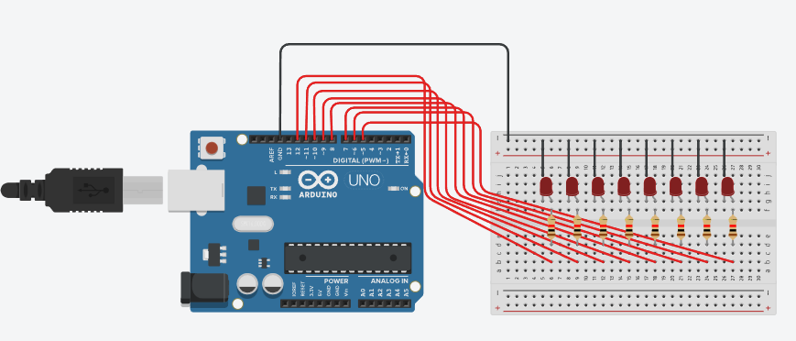

Figure No.1 Ring Counter Display Circuit Diagram

**Components Used**

1. 8 LEDs
2. Resistor
3. Breadboard

**CODE:**

// Ring Counter display for eight (8) LEDs starting from left

void setup()

{

Serial.begin(9600);

pinMode(5, OUTPUT);

pinMode(6, OUTPUT);

pinMode(7, OUTPUT);

pinMode(8, OUTPUT);

pinMode(9, OUTPUT);

pinMode(10, OUTPUT);

pinMode(11, OUTPUT);

pinMode(12, OUTPUT);

}

void loop(){

digitalWrite(12, HIGH);

delay(500);

Serial.println("The LED1 is HIGH");

digitalWrite(12, LOW);

delay(500);

Serial.println("The LED1 is LOW");

digitalWrite(11, HIGH);

delay(500);

Serial.println("The LED2 is HIGH");

digitalWrite(11, LOW);

delay(500);

Serial.println("The LED2 is LOW");

digitalWrite(10, HIGH);

delay(500);

Serial.println("The LED3 is HIGH");

digitalWrite(10, LOW);

delay(500);

Serial.println("The LED3 is LOW");

digitalWrite(9, HIGH);

delay(500);

Serial.println("The LED4 is HIGH");

digitalWrite(9, LOW);

delay(500);

Serial.println("The LED4 is LOW");

digitalWrite(8, HIGH);

delay(500);

Serial.println("The LED5 is HIGH");

digitalWrite(8, LOW);

delay(500);

Serial.println("The LED5 is LOW");

digitalWrite(7, HIGH);

delay(500);

Serial.println("The LED6 is HIGH");

digitalWrite(7, LOW);

delay(500);

Serial.println("The LED6 is LOW");

digitalWrite(6, HIGH);

delay(500);

Serial.println("The LED7 is HIGH");

digitalWrite(6, LOW);

delay(500);

Serial.println("The LED7 is LOW");

digitalWrite(5, HIGH);

delay(500);

Serial.println("The LED8 is HIGH");

digitalWrite(5, LOW);

delay(500);

Serial.println("The LED8 is LOW");

}

**OUTPUT:**

IV. Conclusion

*This laboratory activity provided us with an opportunity to apply our Arduino programming and circuit diagram design skills, culminating in the creation of a functional ring counter circuit that ligts eight (8) LEDs sequentially from left to right. Utilizing the capabilities of the Tinkercad Software, the proponent executed these tasks. Furthermore, this exercise enhanced the student's comprehension of key concepts, including the utilization of digitalWrite for pin control and the specific pin assignments. Finally, the student gained a deeper understanding of the underlying logic governing the circuit's operation.*

**References**

[1] D.J.D. Sayo. “University of the City of Manila Computer Engineering Department Honor Code,” PLM-CpE Departmental Policies, 2020.